Lab 6

Isaiah Hoffer

PART A:

LAB Q A1 RESULT:

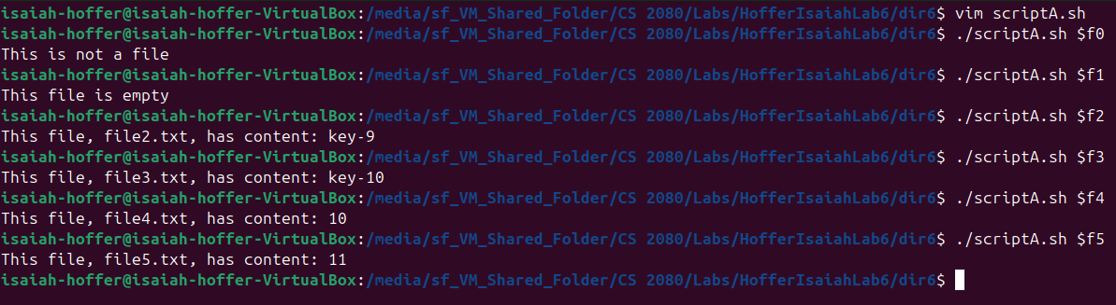

LAB Q A1 SCRIPT:

#!/bin/bash

#Checking If File Exists

if [[ ! -f $1 ]]; then

#If File Does Not Exist

echo "This is not a file"

elif [[ -z $(cat $1) ]]; then

#If File Is Empty

echo "This file is empty"

else

#If File Exists And Is Not Empty

echo "This file, $1, has content: $(cat $1)"

fi #End If Statement

exit

LAB Q A2 RESULT:

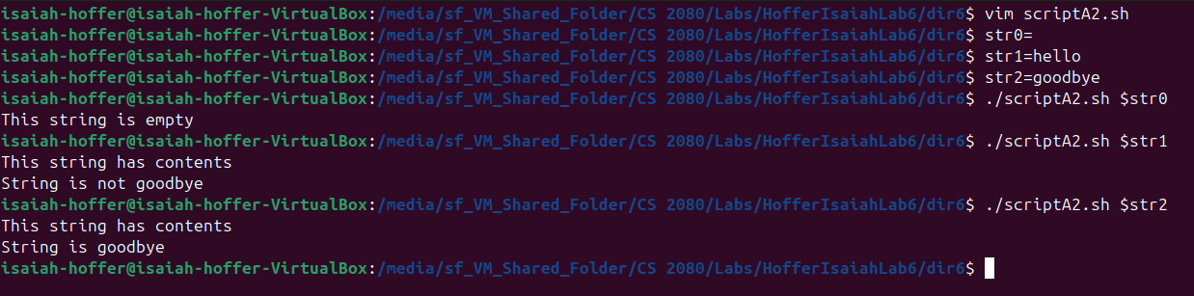

LAB Q A2 SCRIPT:

#! /bin/bash

if [[ -z $1 ]]; then

#If String Is Empty

echo "This string is empty"

else

#If String Is Not Empty

echo "This string has contents"

if [[ $1 == "goodbye" ]]; then

#If String Says Goodbye

echo "String is goodbye"

else

#String Says Anything Else

echo "String is not goodbye"

fi #End Nested If Statement

fi #End If Statement

exit

LAB Q A3 RESULT:

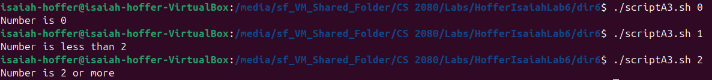

LAB Q A3 SCRIPT:

#! /bin/bash

if [[ $1 == 0 ]]; then

#If $1 ==0

echo "Number is 0"

elif [[ $1 < 2 ]]; then

#If $1 < 2

echo "Number is less than 2"

else

#If $1 >= 2

echo "Number is 2 or more"

fi #Closing If Statement

exit

PART B:

LAB Q B1 RESULT:

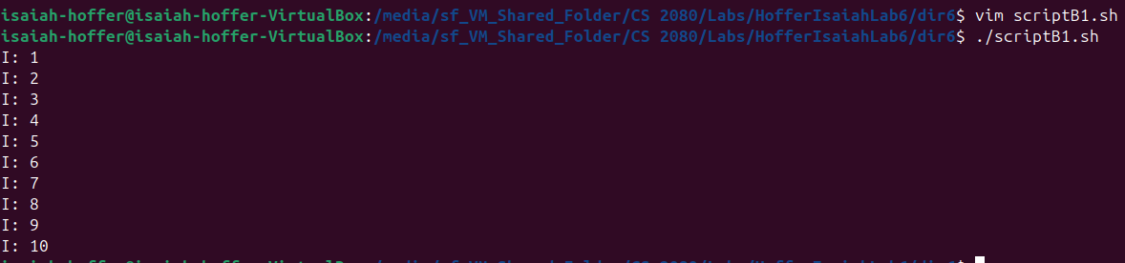

LAB Q B1 SCRIPT:

#! /bin/bash

#Counter

for (( i = 1; i <= 10; i++)); do

echo "I: $i"

done

exit

LAB Q B2 RESULT:

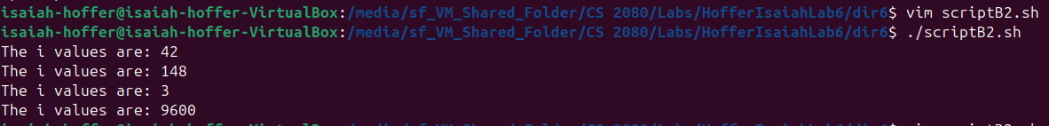

LAB Q B2 SCRIPT:

#! /bin/bash

for i in 42 148 3 9600

do

echo "The i values are: $i"

done

exit

LAB Q B3 RESULT:

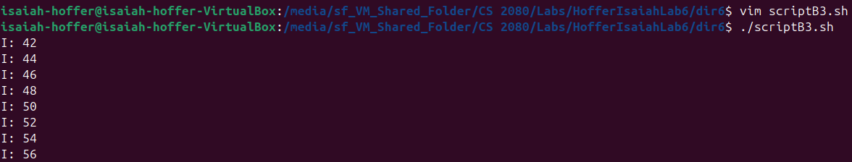

LAB Q B3 SCRIPT:

#! /bin/bash

for i in {42..56..2}; do

echo "I: $i"

done

exit

LAB Q B4 RESULT:

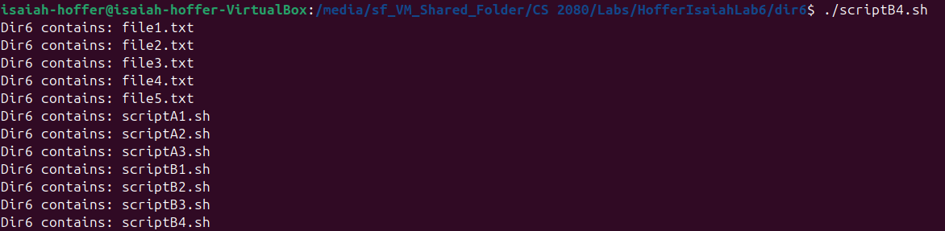

LAB Q B4 SCRIPT:

#! /bin/bash

for file in *; do

echo "Dir6 contains: $file"

done

exit

LAB Q B5 RESULT:

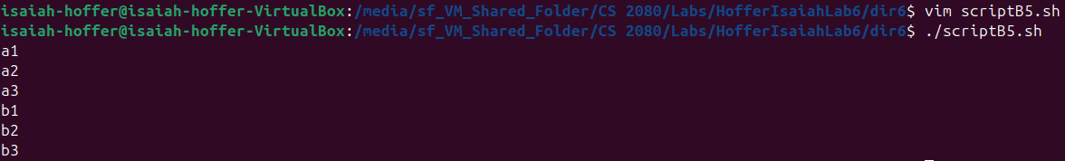

LAB Q B5 SCRIPT:

#! /bin/bash

for i in {a,b}{1..3}; do

echo $i

done

exit

PART C:

LAB Q C1:

[[ -f ./file1.txt ]] || echo "False"

LAB Q C2:

[[ -d ./file.txt ]] && echo "True"

LAB Q C3:

(( 48 > 42 )) || echo "False"

PART D:

LAB Q D1 RESULT:

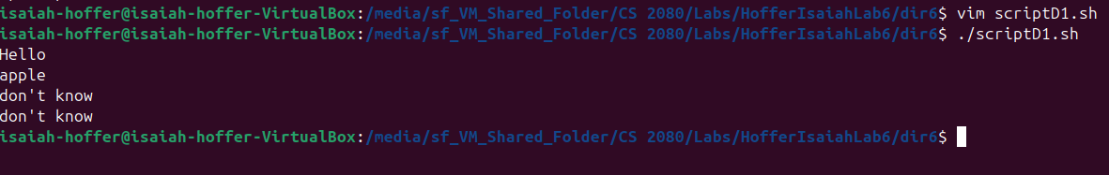

LAB Q D1 SCRIPT:

#! /bin/bash

#ScriptD1.sh

for string in hello apple happy Thursday; do

case $string in

hello ) echo "Hello";;

apple ) echo "apple";;

* ) echo "don't know";;

esac

done

exit

LAB Q D2 RESULT:

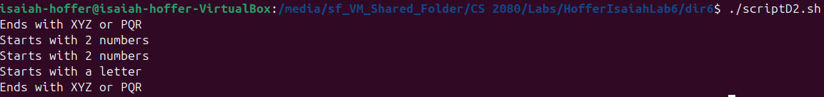

LAB Q D2 SCRIPT:

#! /bin/bash

#ScriptD2.sh

for string in 1abcXYZ "34" "243" A24 2aaaPQR; do

case $string in

[a-zA-Z]* ) echo "Starts with a letter" ;;

[0-9][0-9]* ) echo "Starts with 2 numbers" ;;

*XYZ | *PQR ) echo "Ends with XYZ or PQR" ;;

*[aA]* ) echo "Contains an a" ;;

* ) echo "Found something else" ;;

esac

done

exit

PART E:

LAB Q E1 RESULT:

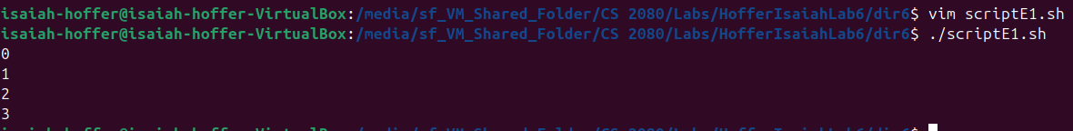

LAB Q E1 SCRIPT:

#! /bin/bash

#ScriptE1.sh

count=0

while (( count < 4 )); do

echo $count

(( count++ ))

done

exit

LAB Q E2 RESULT:

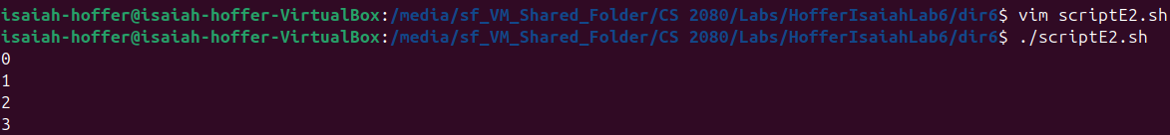

LAB Q E2 SCRIPT:

#! /bin/bash

#ScriptE1.sh

count=0

> count_result.txt

while (( count < 4 )); do

echo $count >> count_result.txt

(( count++ ))

done

cat count_result.txt

exit

LAB Q E3 RESULT:

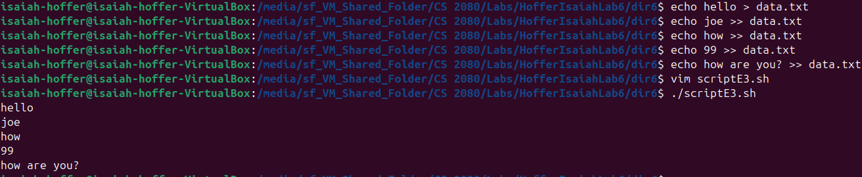

LAB Q E3 SCRIPT:

#! /bin/bash

#ScriptE3.sh

while read line; do

echo $line

done < data.txt

exit

LAB Q E4 RESULT:

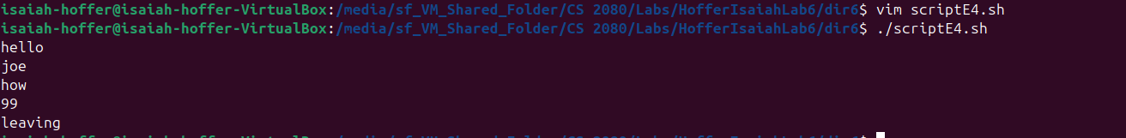

LAB Q4 SCRIPT:

#! /bin/bash

#ScriptE4.sh

while read line; do

echo $line

if [[ $line == *99* ]]; then

echo "leaving"

break

fi

done < data.txt

exit

LAB Q E5 RESULT:



For the last line that had more than 5 words, the fifth word and until the end of the line counted as one word.

LAB Q E5 SCRIPT:

# ! /bin/bash

#ScriptE5.sh

while read word1 word2 word3 word4 word5; do

echo "First Word: $word1 ---- Fifth Word: $word5"

done < example_file.txt

exit

LAB Q E6 RESULT:



LAB Q E6 SCRIPT:

#! /bin/bash

#ScriptE6.sh

while read line; do

echo $line

done

exit